Douglas College

ECON1150-005

Principles of Microeconomics

Assignment #4

Students: Dawu, Kajol, Hug Nam Le

1. Chapter 8, Problem #6.
2. The level of output = average product of each labor x labor = 30 x 20 =600

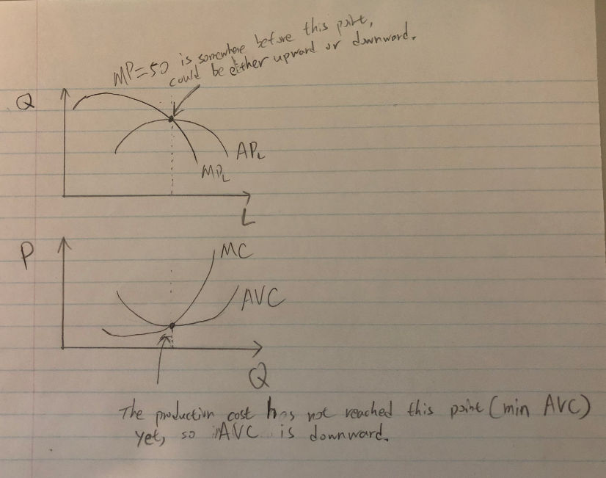

1. At this point, MPL = 50 > APL =30, the firm should keep producing(some where in stage 1 or 2, but before the interception point of stage 2).

So we can not know the MC curve is upward or downward.

1. We know that the MPL, APL curves and MC, AVC curves are have a inverse relationship, and the firm has not reached the point where MPL and APL intercept yet(min AVC point). As we can see from the graph, the AVC curve is decreasing.

2. Chapter 8, Problem #8.

a. False, average product is increasing when marginal product is MORE than the average product.

b. False, average product is positive when total product is positive even if the marginal product is negative.

c. False, if average product is positive, but marginal product is negative, total product is still decreasing.

d. False, if total product is increasing, marginal product can still be decreasing, marginal product only needs to remain positive.

e. False, even when marginal product start to fall below average product, as long as the marginal product remains positive, total product is increasing.

3. Chapter 9, Problem #2.

Marginal cost (the cost of the 1000th box) = TC of 1000box - TC of the first 999 box

=$1.01 x 1000 - $1.0 x 999 = $11

Jean only offers $5 (revenue of the 1000th box), so the 1000th box will have a negative profit.

So, I should not accept his offer.

1. Chapter 9, Problem #14.

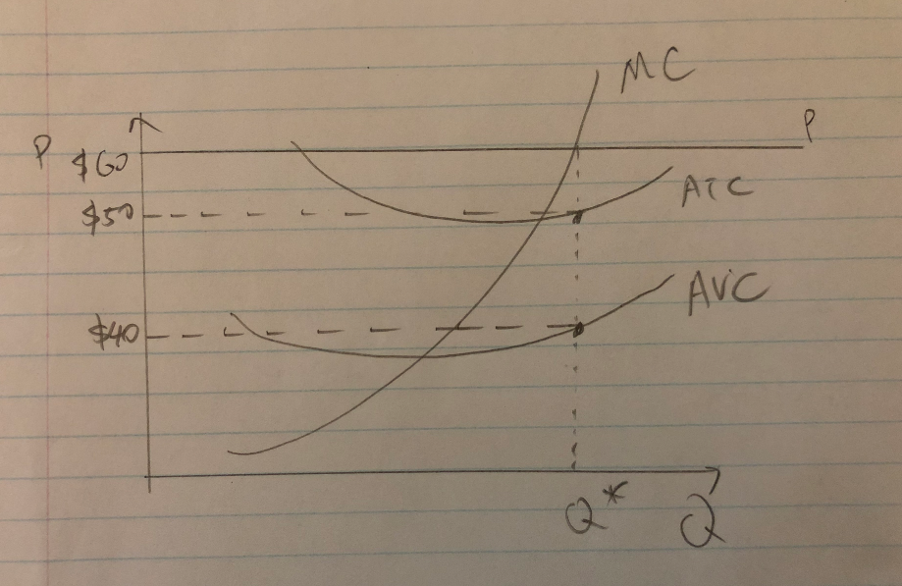

1. FC = TC-TVC = ATCxQ - AVCxQ = $50x100 - $40x100 = $1000
2. Profit = TR - TC = PxQ - ATCxQ = $60x100 - $50x100 = $1000
3. Rent = (P-AVC)xQ = ($60 - $40)x100 = $2000

Or Rent = FC +Profit = $1000+$1000=$2000

1. No. ATC is at minimum when ATC curve and MC curve intercept. If the firm is producing at minimum ATC, then MC = ATC=$50. But the firm is maximizing profit, that means MC = P = $60. So the firm is not producing where the ATC at minimum.
2. The firm is maximizing profit ==> MC= Prize = $60
3. Chapter 9, Problem #20.
4. From a community point of view, when any local firm makes a loss, it doesn’t really mean anything to the community. But it is not a positive contribution to the community, when the firm is making a loss, some firms (sponsors) will leave the market, thus decrease the amount of concerts/music festivals being held for the community.
5. No, this does not make economic sense. As the dance club doesn’t need to may the rent, but the opportunity cost will go up. Therefore, AVC will go up, and profit will be back to zero again. Quantify (audience) will remain the same.
6. Chapter 10, Problem #2. (For part (a), assume apples and peanuts are substitutes in consumption.)

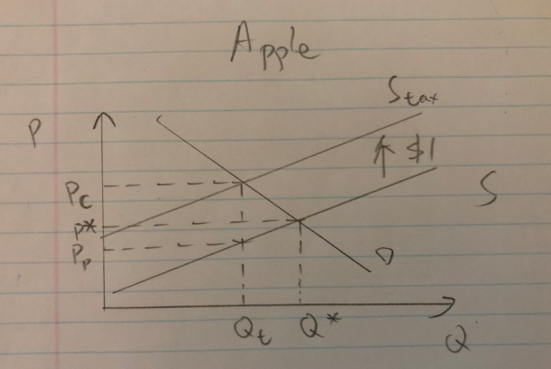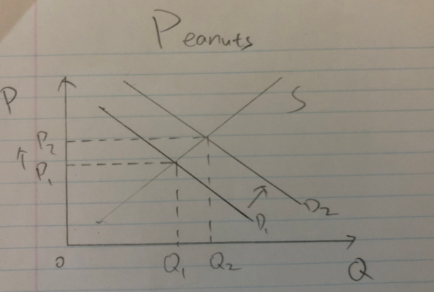

1. When the tax is added for apple, consumer’s price of apple will increase from P\* to Pc. As apples and peanuts are substitute, the demand of of peanuts will increase from D1 to D2, so the price of peanuts will increase from P1 to P2.
2. Price for the producer has decreased to Pp. So the value of apple tree decreases, and it is not costless to remove the tree,so the value of apple land will decrease.
3. Since apples and peanuts are substitute, change in apple price will not effect the total demand of apples and peanuts. The value of general farm tractor will remain the same.
4. Specific apple growing equipment and apples are complement, so the value of the equipment will go down.
5. Chapter 10, Problem #24.

a.

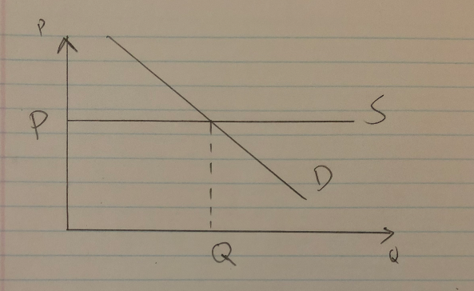

Because this industry is made up of identical firms, the supply curve is a horizontal line. Equilibrium price is P, quantity is Q.

b.

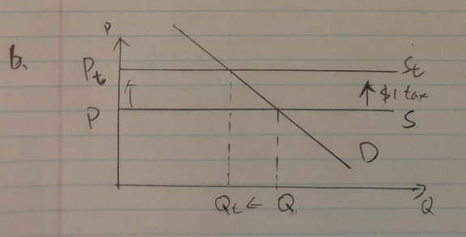

This $1 per unit tax causes the supply curve shift upward by $1, from P to Pt. The price is increased by $1.

c.



Lump sum tax only increases the fixed cost, not variable cost. The marginal cost for each unit doesn’t change. So the marginal cost curve, which is the supply curve in this case is not affected by this tax. So the graphic is just the same as it is in a). The price will remain the same.

1. Chapter 10, Problem #26.

a.

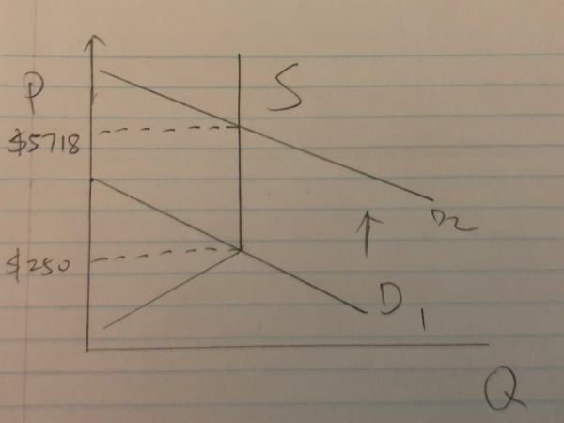

Because Nike producers sneakers in “batches” , that mean the when the fixed amount of batch is released, the supply becomes vertical(no production until further batch releases).

b.

Just before the release the of the shoes, there would be a huge line up outside the shoe store. Because the opportunity cost for these fellows is only $10/hour, after they buy the shoes, they resell them on eBay when the demand gets really high and earn a huge profit.

c.

Since the profit is huge for those who plan to sale in the future, they would keep doing this until the shoes are sold out. (5718-250)/10 = 54.68 hours, in reality not many people could wait this long, and the shoes would be already sold out.